
FAKE NEWS DETECTION AND VISUALIZATION PLATFORM

A MAIN PROJECT REPORT

Submitted by

ASWIN CHACKO JEEMON
MLM24MCA-2020

To

The APJ Abdul Kalam Technological University in Partial fulfillment of the requirements for
the award of the degree

of

MASTER OF COMPUTER APPLICATIONS

Under the Guidance of

Ms. DIYVA S B

(HOD & Associate Professor, Department of Computer Applications)


DEPARTMENT OF COMPUTER APPLICATIONS MANGALAM COLLEGE OF ENGINEERING, ETTUMANOOR
(Affiliated to APJ Abdul Kalam Technological University)

APRIL 2026



MANGALAM COLLEGE OF ENGINEERING
Accredited by NAAC& ISO 9001:2000 Certified Institution
DEPARTMENT OF COMPUTER APPLICATIONS
VISION
To become a centre of excellence in computer applications,competent in the global ecosystem with technical knowledge,innovation with a sense of social commitment.
MISSION
- To serve with state of the art education,foster advanced research and cultivate innovation in the field of computer applications.
- To prepare learners with knowledge skills and critical thinking to excel in the technological landscape and contribute positively to society.
Program Educational Objectives
- PEO I :Graduates will possess a solid foundation and in-depth understanding of computer applications and will be equipped to analyze real-world problems, design and create innovative solutions, and effectively manage and maintain these solutions in their professional careers.
- PEO II: Graduates will acquire technological advancements through continued education, lifelong learning and research, thereby making meaningful contributions to the field of computing.
- PEO III: Graduates will cultivate team spirit, leadership, communication skills, ethics, and social values, enabling them to apply their understanding of the societal impacts of computer applications effectively.
Program Specific Outcomes
- PSO I: Apply advanced technologies through innovations to enhance the efficiency of design and development.
- PSO II: Apply the principles of computing to analyze, design and implement sustainable solutions for real world challenges.

MAPPING OF PO-PSO-SDG

MAPPING WITH PROGRAM OUTCOMES (POs):

SL.NO | POs ADDRESSED | RELEVANCE TO PROJECT
1 | PO1 | Applies programming logic, data handling, and basic  mathematical concepts to implement semantic verification, OCR processing, and real-time visualization of fake news detection  results.
2 | PO2 | Analyzes the real-world problem of misinformation by studying trusted news sources, multilingual challenges, and verification  strategies to reach meaningful conclusions.
3 | PO3 | Designs and develops an innovative AI-based solution that verifies news in real time and visualizes results instantly,  addressing societal concerns related to fake news dissemination.
4 | PO4 | Uses modern tools such as semantic AI models, Streamlit  dashboards, OCR libraries, RSS feeds, and data visualization frameworks with awareness of their limitations.
5 | PO6 | Applies project management principles such as modular design, scheduling, task breakdown, and efficient resource utilization to develop a scalable and maintainable verification platform.
6 | PO7 | Addresses ethical responsibilities by verifying information only through trusted publishers, reducing misinformation, and supporting responsible and transparent information sharing.
7 | PO8 | Encourages continuous learning through the adoption of evolving AI, NLP, visualization techniques, and real-time data processing technologies.

LIST OF PROGRAM OUTCOMES (POs):
PO1 (Foundation Knowledge): Apply knowledge of mathematics, programming logic and coding fundamentals for solution architecture and problem solving.
PO2 (Problem Analysis): Identify, review, formulate and analyse problems for primarily focussing on customer requirements using critical thinking frameworks.

PO3 (Development of Solutions): Design, develop and investigate problems with as an innovative approach for solutions incorporating ESG/SDG goals.
PO4 (Modern Tool Usage): Select, adapt and apply modern computational tools such as development of algorithms with an understanding of the limitations including human biases.
PO5 (Individual and Teamwork): Function and communicate effectively as an individual or a team leader in diverse and multidisciplinary groups. Use methodologies such as agile.
PO6 (Project Management and Finance): Use the principles of project management such as scheduling, work breakdown structure and be conversant with the principles of Finance for profitable project management.
PO7 (Ethics): Commit to professional ethics in managing software projects with financial aspects. Learn to use new technologies for cyber security and insulate customers from malware.
PO8 (Life-long learning): Change management skills and the ability to learn, keep up with contemporary technologies and ways of working.

MAPPING WITH PROGRAM SPECIFIC OUTCOMES (PSOs):
SL.NO | PSOs ADDRESSED | RELEVANCE TO PROJECT
1 | PSO 1 | Apply advanced technologies such as semantic artificial  intelligence, multilingual natural language processing, OCR, and real-time data visualization to design and develop an  efficient fake news detection and result visualization platform that improves accuracy, usability, and verification efficiency.
2 | PSO 2 | Apply core computing principles including data analysis, algorithm design, and system integration to analyze  misinformation challenges and implement a sustainable,  real-time fake news verification solution using trusted news sources and modern computing tools.

LIST OF PROGRAM SPECIFIC OUTCOMES (PSOs):
PSO 1: Apply advanced technologies through innovations to enhance the efficiency of design and development.
PSO 2: Apply the principles of computing to analyze, design and implement sustainable solutions for real world challenges.

2. MAPPING WITH SUSTAINABLE DEVELOPMENT GOALS (SDGs):
SDG NO | SDGs ADDRESSED | RELEVANCE TO PROJECT
SDG 9 | Industry, Innovation, and Infrastructure | The project helps reduce the spread of misinformation and fake news in digital  platforms. It promotes reliable information systems and supports responsible digital  communication.
SDG 16 | Peace, Justice, and Strong Institutions | The project contributes to reducing  misinformation and fake news, which are major threats to democratic institutions, social harmony, and justice, thereby supporting transparent and accountable  information systems.

SUSTAINABLE DEVLOPMENT GOALS (SDGs):
SDG 1 – No Poverty-End poverty in all its forms everywhere.
SDG 2 – Zero Hunger-End hunger, achieve food security and improved nutrition, and promote sustainable agriculture.
SDG 3 – Good Health and Well-Being-Ensure healthy lives and promote well-being for all at all ages.
SDG 4 – Quality Education-Ensure inclusive and equitable quality education and promote lifelong learning opportunities for all.
SDG 5 – Gender Equality-Achieve gender equality and empower all women and girls.
SDG 6 – Clean Water and Sanitation-Ensure availability and sustainable management of water and sanitation for all.
SDG 7 – Affordable and Clean Energy-Ensure access to affordable, reliable, sustainable, and modern energy for all.
SDG 8 – Decent Work and Economic Growth-Promote sustained, inclusive, and sustainable economic growth, full and productive employment, and decent work for all.
SDG 9 – Industry, Innovation, and Infrastructure-Build resilient infrastructure, promote inclusive and sustainable industrialization, and foster innovation.
SDG 10 – Reduced Inequality-Reduce inequality within and among countries.
SDG 11 – Sustainable Cities and Communities-Make cities and human settlements inclusive, safe, resilient, and sustainable.

SDG 12 – Responsible Consumption and Production-Ensure sustainable consumption and production patterns.
SDG 13 – Climate Action-Take urgent action to combat climate change and its impacts.
SDG 14 – Life Below Water-Conserve and sustainably use the oceans, seas, and marine resources. SDG 15 – Life on Land -Protect, restore, and promote sustainable use of terrestrial ecosystems, manage forests sustainably, combat desertification, halt and reverse land degradation, and halt biodiversity loss.
SDG 16 – Peace, Justice, and Strong Institutions- Promote peaceful and inclusive societies, provide access to justice for all, and build effective, accountable, and inclusive institutions.
SDG 17 – Partnerships for the Goals -Strengthen the means of implementation and revitalize the global partnership for sustainable development.

MANGALAM COLLEGE OF ENGINEERING, ETTUMANOOR DEPARTMENT OF COMPUTER APPLICATIONS
APRIL 2026


DECLARATION

I hereby certify that the work which is being presented in the project entitled “FAKE NEWS DETECTION AND VISUALIZATION PLATFORM” submitted in the DEPARTMENT OF COMPUTER APPLICATIONS is an
authentic record of my own work carried under the supervision of Ms. DIVYA S B, HOD & Associate Professor. This study has not been submitted to any other institution or university for the award of any other degree. This report has been checked for plagiarism by the college and the similarity index is within permissible limits set by the college.

Name & Signature of Student
Date: Place:

MANGALAM COLLEGE OF ENGINEERING, ETTUMANOOR

DEPARTMENT OF COMPUTER APPLICATIONS
APRIL 2026


CERTIFICATE

Certified that the report entitled ‘Fake News Detection and Visualization Platform’ submitted by ASWIN CHACKO JEEMON (MLM24MCA-2020) to the APJ Abdul Kalam Technological University in partial fulfilment of the requirements for the award of the DEGREE OF MASTER OF COMPUTER APPLICATIONS by APJ ABDUL KALAM TECHNOLOGICAL UNIVERSITY is a bonafide record
of the MAIN PROJECT work carried out by him under our guidance and supervision during the academic year 2025-26.

PROJECT GUIDE

Ms. Divya S B
HOD & Associate Professor
Department Of Computer Applications
PROJECT COORDINATOR

Ms. Banu Sumayya S Assistant Professor
Department of Computer Applications

HEAD OF THE DEPARTMENT EXTERNAL EXAMINER

Ms. Divya S B
HOD & Associate Professor
Department of Computer Application

ACKNOWLEDGEMENT

I am greatly indebted to the authorities of Mangalam College of Engineering for providing the necessary facilities to successfully complete my Project on the topic “Fake News Detection and Visualization Platform”.

I express my sincere thanks to Dr. Vinodh P Vijayan, Principal, Mangalam College of Engineering for providing the facilities to complete my Project successfully.

I thank and express my solicit gratitude to Ms. Divya S B, HOD, Department of Computer Applications, Mangalam College of Engineering, for her invaluable help and support which helped me a lot in successfully completing this Project work.

I express my gratitude to my Internal Guide, Ms. Divya S B, Associate professor, Department of Computer Applications for the suggestions and encouragement which helped in the successful completion of my Project.

Furthermore, I would like to acknowledge with much appreciation the crucial role of the faculties especially Project coordinator, Ms.Banu Sumayya S, Assistant Professor, Department of Computer Applications, Mangalam College of Engineering, who gave the permission to use all the required equipment and the necessary resources to complete the presentation & report.
Finally, I would like to express my heartfelt thanks to my parents who were very supportive both financially and mentally and for their encouragement to achieve my goal.

ASWIN CHACKO JEEMON (MLM24MCA-2020)

ABSTRACT

Fake news and misinformation have become major challenges in today’s digital society, especially with the rapid spread of news through social media and online platforms. False or misleading news can create public panic, damage reputations, influence political opinions, and disrupt social harmony. Many users find it difficult to verify the authenticity of news due to differences in language, headline variations across websites, and the absence of easy-to-use verification tools. To address this issue, this project proposes a Fake News Detection Result Visualization Platform based on semantic artificial intelligence and real-time news verification.
The system allows users to provide news input in the form of text, image (OCR), or URL. The extracted news headline is semantically analyzed using multilingual sentence-transformer models and verified in real time by cross-checking with multiple trusted national and international news websites through RSS feeds and news aggregators. If the news meaning is verified across multiple reliable sources, the system classifies it as Real, Limited Coverage, or Not Verified. The platform also visualizes verification results instantly using tables, logs, and confidence indicators, enabling users to clearly understand the outcome.
This approach reduces the spread of misinformation, supports informed decision-making, and promotes media literacy among users. The proposed system is scalable, language-independent, and does not rely on pre-stored datasets, making it suitable for journalists, students, researchers, and the public. By providing immediate and transparent verification results, the platform contributes to responsible information consumption and a safer digital information ecosystem.

Keywords: Fake News Detection, Machine Learning, Semantic AI, Natural Language Processing, TF-IDF, Data Visualization, News Verification, Misinformation Detection.

Mapping with Sustainable Development Goals (Mention the Goals) | SDG 9- Industry, Innovation, and Infrastructure SDG 16- Peace, Justice, and Strong Institutions

TABLE OF CONTENTS
CHAPTER NO Title Page No

 | ACKNOWLEDGEMENT  ABSTRACT  LIST OF FIGURES  LIST OF ABBREVIATIONS | I II III  IV
Chapter 1: | INTRODUCTION | 1
1.1 | Background | 1
1.2 | Motivation | 1
1.3 | Scope and Objectives | 2
1.4 | Problem Statement | 3
Chapter 2: | REQUIREMENTS AND ANALYSIS | 5
2.1 | Existing system & Problem Statement | 5
2.2 | Solution Overview | 6
2.3 | Feasibility Study | 7
 | 2.3.1 Technical feasibility | 7
 | 2.3.2 Economic Feasibility | 8
 | 2.3.3 Operational Feasibility | 8
Chapter 3: | LITERATURE REVIEW | 10
3.1 | Graph-Based Interpretability for Fake News Detection through Topic- and Propagation-Aware | 10
 | Visualization
3.2 | A Comprehensive Analysis of Fake News  Detection Models: A Systematic Literature Review | 11
 | and Current Challenges
3.3 | Study of Fake News Detection using Machine  Learning and Deep Learning Classification | 12
 | Methods
3.4 | Exploring Machine Learning for Fake News  Detection: Techniques, Tools, Challenges, and | 13
 | Future Research Directions
3.5 | Fake News Detection Model on social media by  Leveraging Sentiment Analysis of News Content | 14
 | and Emotion Analysis of Users’ Comments
  - Detecting Fake News on Social Media Using 14
Propagation Networks
  - Hybrid Deep Learning Models for Fake News 15
Detection

  - Multimodal Fake News Detection Using Text and 16
Image Analysis
  - Knowledge Graph-Based Fake News Detection 17

3.10 | Transformer-Based Fake News Detection Using  BERT | 18
Chapter 4: | DIAGRAMS | 19
4.1 | Data Flow Diagrams | 19
4.2 | Use Case Diagram | 24
4.3 | Class Diagram | 27
4.4 | State Diagram | 30
4.5 | Activity Diagram | 33
4.6 | Sequence Diagram | 35
Chapter 5: | METHODOLOGY | 38
5.1 | Module Descriptions | 38
5.2 | Algorithms | 46
5.3 | System Architecture | 47
Chapter 6: | IMPLEMENTATION DETAILS | 51
6.1 | Implementation Procedures | 51
6.2 | Testing Methods and Results | 56
Chapter 7: | ADVANTAGES AND DISADVANTAGES | 59
7.1 | Advantages | 59
7.2 | Disadvantages | 61
Chapter 8: | RESULTS AND DISCUSSION | 64
8.1 | System Output Overview` | 64
8.2 | Prediction Results | 65
8.3 | Trusted Source Matching | 66
8.4 | Global Truth Index | 66
8.5 | Semantic Entity Extraction | 67
8.6 | Visualization, Analytics, System Performance Evaluation, and Discussion | 68
Chapter 9: | CONCLUSION | 70
9.1 | Summary | 70
9.2 | Limitations | 71
9.3 | Future Scope | 71
9.4 | Applications | 72

Chapter 10: | APPENDICES | 74
Chapter 11: | REFERENCES | 78

LIST OF FIGURES

FIGURE NO. | TITLE | PAGE NO
4.1 | DFD Level 0 | 20
4.2 | DFD Level 1 | 22
4.3 | Use case diagram | 25
4.4 | Class Diagram | 30
4.5 | State Diagram | 31
4.6 | Activity Diagram | 35
4.7 | Sequence Diagram | 36
5.1 | Home | 39
5.2 | Text Verification | 40
5.3 | Result | 42
5.4 | Result | 42
5.5 | Image Verifier | 43
5.6 | URL Scanner | 44
5.7 | Global Analysis | 45
5.8 | Global Analysis | 46
5.9 | Architecture | 48

LIST OF ABBREVIATIONS

ABBREVIATION FULL FORM
API - Application Programming Interface
AI - Artificial Intelligence
ML - Machine Learning
NLP - Natural Language Processing
TF-IDF - Term Frequency – Inverse Document Frequency
OCR - Optical Character Recognition
SVM - Support Vector Machine
URL - Uniform Resource Locator

  - Background

CHAPTER 1 INTRODUCTION

With the rapid expansion of the internet and social media platforms, information can spread across the world within seconds. While this accessibility has greatly improved communication and knowledge sharing, it has also created an environment where misinformation and fabricated news can easily circulate among the public. Fake news refers to misleading or completely false information presented as legitimate news. Such content often spreads rapidly through social media platforms, blogs, and online news portals. Because many users rely on digital media as their primary source of information, distinguishing between authentic and fake content has become increasingly difficult. The impact of fake news extends beyond simple misinformation. It can influence public opinion, affect political decisions, create social unrest, and damage the credibility of legitimate news organizations. In recent years, several incidents have demonstrated how false information can trigger panic, shape election outcomes, and spread harmful rumors. These challenges highlight the urgent need for technological solutions that can help detect and analyze misleading information automatically. Advances in machine learning and natural language processing have opened new opportunities for building systems capable of analyzing large volumes of textual data. By applying these techniques, it is possible to develop intelligent systems that examine the linguistic patterns, credibility indicators, and contextual information of news articles. A fake news detection and visualization platform aims to assist users in identifying unreliable information by providing automated analysis and clear visual representations of the results.

Motivation

The motivation behind developing a fake news detection system stem from the growing impact of misinformation on modern society. With the widespread adoption of smartphones and social media platforms, people are constantly exposed to large volumes of information from various sources. Unfortunately, not all of this information is reliable, and many individuals unknowingly consume and share misleading content. One of the main challenges associated with fake news is the speed at which it spreads across digital platforms. Social media algorithms often promote content that generates high levels of engagement, which may unintentionally amplify sensational or misleading stories. As a result, fake news can reach millions of users within a very short period of time. Another important factor that motivates the development of automated fake news detection systems is the difficulty individuals face

in verifying the credibility of news sources. Many readers lack the time or resources to cross-check information with reliable sources. Consequently, misinformation can spread rapidly before it is corrected by fact-checking organizations. Artificial intelligence technologies offer promising solutions for addressing these challenges. Machine learning algorithms can analyze large volumes of textual data and identify patterns associated with fake news. At the same time, semantic analysis techniques can evaluate the contextual relationships within the text to detect inconsistencies and misleading information. The motivation of this project is to develop a platform that assists users in evaluating the credibility of news articles using automated analysis. By combining machine learning and semantic verification techniques, the proposed system aims to provide more accurate and reliable detection resultsIn addition to detection capabilities, the project emphasizes the importance of visualization in presenting analytical results. Visualization tools enable users to understand complex analytical processes through graphs and charts, making the system more transparent and accessible. Ultimately, the goal of this project is to contribute to the fight against misinformation by providing users with an intelligent tool that supports informed decision-making when consuming online news.

Scope & Objectives

The scope of this project focuses on developing a hybrid fake news detection platform capable of analyzing textual news articles and identifying potential misinformation. The system is designed to process news content using natural language processing techniques, machine learning models, and semantic analysis methods. The platform allows users to submit news articles either by entering a news URL or by directly providing the article text. The system then extracts and processes the textual content before applying a hybrid verification process. The results of the analysis are presented through visualization tools that help users understand the credibility of the news article. The key objectives of the project are as follows:

    - To design and implement an automated fake news detection system using artificial intelligence techniques.
    - To apply natural language processing methods for analyzing textual news content.
    - To develop machine learning models capable of classifying news articles as real or fake.
    - To incorporate semantic analysis techniques that evaluate the contextual meaning of news content.
    - To implement a hybrid verification system that combines machine learning and semantic analysis results.

    - To develop visualization tools that present analytical results through graphical representations.
    - To improve the reliability and transparency of fake news detection systems.

The system is intended to assist users in evaluating the credibility of online news content. Although the platform may not guarantee perfect accuracy, it provides valuable insights that help users identify potential misinformation.

Problem Statement

The rapid growth of digital communication platforms has made it easier than ever for information to spread across the internet. While this has improved access to news and knowledge, it has also created an environment where misleading or fabricated information can spread quickly and widely.

Fake news articles are often designed to resemble legitimate news content, making it difficult for readers to distinguish between genuine and misleading information. Many individuals share news articles without verifying their authenticity, which further contributes to the spread of misinformation.

Traditional fact-checking methods rely heavily on manual analysis performed by journalists and fact-checking organizations. Although these methods can be reliable, they are often too slow to respond to the rapid dissemination of fake news on digital platforms. As a result, misinformation may reach a large audience before it is corrected.

Another challenge is that many existing automated fake news detection systems rely solely on machine learning models that analyze statistical patterns in textual data. While these models can be effective in certain cases, they may fail to detect subtle forms of misinformation that require deeper contextual understanding.

Therefore, there is a need for a more advanced fake news detection system that integrates multiple analytical approaches. The system should be capable of analyzing both the statistical patterns and the contextual meaning of news articles to provide more reliable detection results.

The Fake News Detection and Visualization Platform proposed in this project aims to address this challenge by implementing a hybrid verification approach that combines machine learning classification with semantic analysis techniques.

CHAPTER 2 REQUIREMENTS AND ANALYSIS

Existing System & Problem Statement

With the rapid development of digital communication technologies, news consumption has shifted significantly from traditional media sources to online platforms and social media networks. People now rely heavily on websites, blogs, and social media channels for accessing news and current events. While this shift has improved accessibility and speed of information dissemination, it has also created a major challenge regarding the authenticity of information.

Existing systems for identifying fake news primarily rely on manual verification methods carried out by fact-checking organizations and journalists. These organizations examine suspicious news articles, verify the claims using credible sources, and publish reports indicating whether the information is accurate or misleading. Although this approach can be reliable, it has several limitations.

One of the major limitations of manual verification is the time required to analyze each piece of information. With thousands of news articles published online every minute, manual verification processes cannot keep up with the rapid spread of misinformation. As a result, fake news can reach a large audience before it is identified and corrected.

Another limitation is the reliance on human expertise. Fact-checking requires trained professionals who can analyze the credibility of sources and verify factual claims. However, the number of available fact-checkers is limited compared to the massive volume of online content being produced daily.

Some automated fake news detection systems have been developed using machine learning techniques. These systems analyze textual patterns within news articles to determine whether the content is likely to be fake or genuine. However, many existing machine learning-based systems rely primarily on statistical features such as word frequency and writing style. While these features can be useful, they may not capture deeper contextual relationships within the text.

Additionally, fake news creators continuously adapt their strategies to bypass detection systems. As a result, detection models that rely solely on statistical analysis may fail to identify more sophisticated forms of misinformation.

The problem therefore lies in the lack of a comprehensive system capable of analyzing both the statistical patterns and contextual meaning of news content. A more advanced solution is needed that integrates multiple analytical approaches to improve detection accuracy and reliability.

Solution Overview

To address the limitations of existing systems, the proposed Fake News Detection and Visualization Platform introduces a hybrid verification approach that combines machine learning classification with semantic artificial intelligence techniques.

The proposed system is designed to automatically analyze news articles and determine their credibility using a structured analytical pipeline. The platform accepts news articles as input either in the form of a URL or direct textual content. The system then extracts the relevant information and processes the text using natural language processing techniques.

The first stage of the solution involves text preprocessing, where the extracted content is cleaned and standardized. This stage removes unnecessary elements such as punctuation, stop words, and special characters to prepare the text for analysis.

After preprocessing, feature extraction techniques such as Term Frequency–Inverse Document Frequency (TF-IDF) are used to convert textual data into numerical representations. These numerical vectors allow machine learning algorithms to analyze patterns within the text.

A machine learning classification model is then applied to analyze the textual features and generate a probability score indicating whether the news article is likely to be fake or genuine. This classification process is based on patterns learned from previously labeled datasets containing examples of both fake and real news articles.

In addition to machine learning analysis, the system incorporates a semantic verification module. This module focuses on understanding the contextual meaning of the text and

identifying inconsistencies in relationships between entities, events, and concepts mentioned in the article.

The semantic analysis module examines whether the information presented in the article is logically consistent and contextually accurate. By evaluating these contextual relationships, the system can identify misleading information that may not be detected through statistical analysis alone.

The outputs of the machine learning module and the semantic verification module are combined using a hybrid verification engine. This engine integrates the results from both analytical approaches to produce a final prediction regarding the authenticity of the news article.

Finally, the system presents the results through a visualization dashboard. The dashboard displays graphical representations such as confidence scores, keyword importance charts, and credibility indicators. These visual insights help users understand the reasoning behind the classification result.

By combining automated detection techniques with visual analytics, the proposed system provides a comprehensive and user-friendly solution for identifying fake news.

Feasibility Study

A feasibility study is conducted to evaluate whether the proposed system can be successfully implemented and deployed. The feasibility study examines several important factors including technical feasibility, economic feasibility, and operational feasibility.

Technical Feasibility

Technical feasibility refers to the availability of technologies and tools required to develop the proposed system. The Fake News Detection and Visualization Platform can be implemented using widely available software technologies and machine learning frameworks.

Programming languages such as Python provide extensive support for machine learning and natural language processing tasks. Libraries such as Scikit-learn, TensorFlow, and NLTK offer powerful tools for developing machine learning models and performing text analysis.

Web scraping tools such as BeautifulSoup and Requests can be used to extract news content from online sources. Visualization libraries such as Matplotlib, Plotly, and Seaborn enable the creation of interactive dashboards that display analytical results.

Because these technologies are open-source and well-documented, the development of the system is technically feasible and can be completed using commonly available resources.

Economic Feasibility

Economic feasibility evaluates the cost involved in developing and maintaining the proposed system. The Fake News Detection and Visualization Platform can be developed using open- source tools and libraries, which significantly reduces development costs.

The project does not require expensive hardware or proprietary software licenses. Most of the required tools, including programming environments and machine learning frameworks, are freely available.

In addition, the system can be deployed on standard computing platforms without requiring specialized infrastructure. This makes the project economically feasible for educational and research purposes.

Operational Feasibility

Operational feasibility examines how easily the system can be used by its intended users. The proposed platform is designed to be user-friendly and accessible through a simple interface that allows users to analyze news articles quickly.

Users can submit news articles through a straightforward input form, and the system performs the analysis automatically without requiring technical expertise. The results are displayed through visual dashboards that present analytical insights in an easy-to-understand format.

Because the system requires minimal user interaction and provides clear results, it is operationally feasible for a wide range of users including students, researchers, journalists, and general internet users.

CHAPTER 3 LITERATURE REVIEW

Graph-Based Interpretability for Fake News Detection through Topic- and Propagation-Aware Visualization
[Kayato Soga, Soh Yoshida, Mitsuji Muneyasu, Computation Journal, 2024]

The rapid growth of social networking platforms has significantly transformed the way information is created, shared, and consumed. While these platforms have made communication easier and faster, they have also created an environment where misinformation can spread rapidly. Fake news spreads faster than real news because it often contains sensational content designed to capture public attention. This phenomenon has motivated researchers to develop automated systems capable of detecting and analyzing fake news propagation patterns.
Soga et al. proposed a graph-based interpretability framework that focuses on understanding the propagation patterns of fake news within social media networks. Traditional fake news detection approaches rely heavily on analyzing textual content of articles using natural language processing techniques. However, these methods are often limited because fake news creators frequently mimic the writing style of legitimate news articles. As a result, purely content-based detection systems may fail to identify sophisticated misinformation.
To overcome this limitation, the authors explored propagation-based detection methods that analyze how news spreads across social networks. In this approach, the spread of news is modeled as a graph structure where nodes represent posts or users and edges represent sharing relationships such as retweets or reposts. Graph Neural Networks (GNNs) are used to learn structural patterns within these graphs and identify differences between fake news and real news propagation patterns.
Although graph-based models have demonstrated high detection accuracy, they often lack interpretability. Most models can classify news as fake or real but cannot clearly explain the reasoning behind their predictions. To address this issue, the authors proposed a visualization- based interpretability method that combines topic modeling with propagation analysis.
The proposed system uses BERTopic, a modern topic modeling technique, to classify the topics of news articles. These topics are then visualized alongside propagation structures to analyze

how opinions spread within social networks. The authors discovered that fake news tends to spread within clusters of users who share similar opinions or beliefs. This behavior is associated with psychological phenomena such as confirmation bias, where individuals are more likely to believe information that aligns with their existing beliefs.
Experimental evaluation using real-world datasets demonstrated that fake news propagation structures tend to form deeper and more interconnected graphs compared to real news. The proposed visualization approach allows researchers to observe these patterns and understand the reasoning behind graph-based detection models.
This research contributes significantly to improving the interpretability of fake news detection systems and highlights the importance of analyzing social network propagation structures.

A Comprehensive Analysis of Fake News Detection Models: A Systematic Literature Review and Current Challenges
[Alok Mishra, Halima Sadia, Engineering Proceedings, 2023]

Fake news detection has become an important research area due to the widespread use of social media platforms for information sharing. Mishra and Sadia conducted a comprehensive literature review that examines the evolution of fake news detection models and identifies key challenges associated with this problem.
The study analyzes a wide range of approaches used in fake news detection, including machine learning techniques, deep learning models, linguistic analysis methods, and hybrid frameworks. Early fake news detection systems relied on simple rule-based approaches and statistical methods to identify misleading information. However, these approaches were limited in their ability to analyze complex textual patterns.
With the advancement of machine learning technologies, researchers began using supervised learning algorithms such as Support Vector Machines (SVM), Decision Trees, and Random Forest classifiers. These models analyze textual features extracted from news articles to identify patterns associated with fake news.
Feature extraction techniques play an important role in machine learning-based fake news detection. Common techniques include Term Frequency–Inverse Document Frequency (TF- IDF), n-gram analysis, and bag-of-words models. These techniques convert textual data into numerical representations that can be processed by machine learning algorithms.

More recent studies have focused on deep learning models such as Convolutional Neural Networks (CNN), Recurrent Neural Networks (RNN), and Long Short-Term Memory (LSTM) networks. These models are capable of automatically learning hierarchical representations of textual data and capturing complex relationships between words.
The authors also examined the role of datasets in fake news detection research. Several benchmark datasets have been widely used, including the LIAR dataset, FakeNewsNet dataset, and Kaggle fake news datasets. However, the study highlights that many datasets suffer from limitations such as small size, domain specificity, and inconsistent labeling methods.
Another major challenge identified in the study is the rapid evolution of fake news generation techniques. Fake news creators continuously adapt their strategies to bypass detection systems. As a result, detection models must be regularly updated and retrained using new datasets.
The authors conclude that hybrid detection systems that combine multiple analytical approaches are likely to provide the most reliable solutions. These systems integrate textual analysis, social network analysis, and knowledge-based verification techniques to improve detection accuracy.

Study of Fake News Detection using Machine Learning and Deep Learning Classification Methods
[Keshav Nath, Aman Ahuja, Priyansh Soni, Rahul Katarya, Anjum, IEEE]

Nath et al. conducted a comparative study of various machine learning and deep learning models used for fake news detection. The research focuses on evaluating the effectiveness of different classification algorithms and feature extraction techniques in identifying fake news articles.
The authors collected multiple datasets containing news articles, tweets, and social media posts. These datasets were used to train and test different classification models. Before training the models, the textual data underwent several preprocessing steps including punctuation removal, stop word elimination, and tokenization.
Feature extraction techniques such as Bag-of-Words and TF-IDF were used to convert textual data into numerical vectors. These features represent the frequency and importance of words within news articles.
The study evaluated several machine learning algorithms including Logistic Regression, Random Forest, Support Vector Machine, and Naïve Bayes classifiers. In addition, deep

learning models such as Convolutional Neural Networks and Deep Neural Networks were also tested.
Experimental results showed that Random Forest combined with Bag-of-Words features achieved the highest accuracy among the tested models. The system achieved an accuracy of approximately 98.8% on the FARN dataset. The results also indicated that TF-IDF features consistently performed better than many other feature extraction techniques.
The authors concluded that machine learning models can effectively detect fake news when trained on high-quality datasets. However, they also emphasized the importance of selecting appropriate feature extraction techniques to improve classification accuracy.

  - Exploring Machine Learning for Fake News Detection: Techniques, Tools,
Challenges, and Future Research Directions
[Sapana Yakkundi, Rudragoud Patil, Sangeeta Sangani, Discover Applied Sciences, 2025]
This research provides an extensive review of machine learning techniques used for fake news detection and explores the challenges associated with analyzing misinformation in digital media environments.
The study highlights that fake news can appear in multiple forms including textual articles, images, videos, and manipulated multimedia content. As a result, detection systems must be capable of analyzing multiple data modalities simultaneously.
The authors emphasize the importance of multimodal fake news detection systems that analyze both textual and visual information. Multimodal systems integrate natural language processing techniques with computer vision algorithms to detect inconsistencies between textual and visual content.
The study also examines various datasets used in fake news detection research. These datasets include FakeNewsNet, Twitter datasets, and image-based datasets used for detecting manipulated images.
Another important aspect discussed in the study is the lifecycle of fake news generation. Fake news typically goes through four stages: creation, platform selection, dissemination, and propagation. Understanding these stages helps researchers design detection systems that can identify misinformation at different points in the propagation process.

The authors conclude that future research should focus on developing real-time fake news detection systems capable of analyzing multimodal content and adapting to evolving misinformation strategies.

  - Fake News Detection Model on Social Media by Leveraging Sentiment Analysis of
News Content and Emotion Analysis of Users’ Comments
[Suhaib Kh. Hamed, Mohd Juzaiddin Ab Aziz, Mohd Ridzwan Yaakub, Sensors Journal, 2023]

Hamed et al. proposed a fake news detection model that incorporates both sentiment analysis and emotion analysis to improve detection accuracy. The authors observed that fake news often triggers strong emotional reactions among social media users.
The proposed model analyzes both the sentiment expressed in news articles and the emotions expressed in user comments related to those articles. Sentiment analysis techniques are used to identify whether the news content expresses positive, negative, or neutral opinions.
In addition to sentiment analysis, the system also performs emotion analysis on user comments. Fake news often generates emotions such as fear, anger, and surprise among readers. By analyzing these emotional patterns, the system can identify suspicious news articles that generate abnormal emotional responses.
The proposed model uses a Bidirectional Long Short-Term Memory (Bi-LSTM) neural network to analyze sequential textual data. Bi-LSTM networks are capable of capturing long- term dependencies between words and understanding the context of textual content.
Experimental results showed that the proposed model achieved an Area Under Curve (AUC) accuracy of approximately 96.77% when tested on the Fakeddit dataset. These results demonstrate that combining sentiment analysis with emotion analysis can significantly improve fake news detection performance.

Detecting Fake News on Social Media Using Propagation Networks
[Kai Shu, Amy Sliva, Suhang Wang, Jiliang Tang, Huan Liu, ACM Conference]

The rapid spread of misinformation on social media platforms has created significant challenges for researchers and policymakers. Kai Shu and colleagues proposed a propagation-

based fake news detection approach that focuses on analyzing how information spreads across social networks rather than relying solely on textual content.
Traditional fake news detection systems primarily analyze linguistic patterns within news articles. However, fake news authors often mimic the writing style of legitimate journalism, making it difficult for content-based systems to identify misleading information. To overcome this limitation, the authors introduced a propagation network model that analyzes the dissemination patterns of news articles on social media platforms.
In the proposed method, the spread of a news article is represented as a propagation graph. Each node in the graph represents a user who shares or interacts with the news article, while edges represent interactions such as retweets, replies, or reposts. By analyzing these propagation networks, researchers can observe structural patterns associated with fake news. The study revealed that fake news tends to spread faster and deeper within social networks compared to real news. Fake news articles often reach a larger audience within a shorter time because they are designed to attract attention through sensational headlines and emotionally charged content.
The authors used machine learning algorithms to analyze features extracted from propagation networks. These features included propagation depth, network size, user engagement levels, and temporal patterns of information sharing. Experimental results demonstrated that propagation-based features significantly improved fake news detection accuracy.
This research highlights the importance of incorporating social network analysis into fake news detection systems. By combining propagation analysis with textual analysis, detection systems can achieve better performance and identify misinformation more effectively.

Hybrid Deep Learning Models for Fake News Detection
[Shuai Wang, Liang Wu, and Huan Liu, IEEE Transactions]
The increasing complexity of fake news has motivated researchers to explore advanced deep learning models capable of capturing complex textual patterns. Wang et al. proposed a hybrid deep learning architecture that combines multiple neural network models to improve fake news detection performance.
The proposed system integrates Convolutional Neural Networks (CNN) and Recurrent Neural Networks (RNN) to analyze news articles. CNN models are used to extract local textual features such as phrases and word combinations, while RNN models capture sequential dependencies within the text.

This hybrid architecture allows the system to analyze both the structural patterns of sentences and the contextual relationships between words. By combining these two approaches, the model can better understand the linguistic characteristics of fake news.
The researchers conducted experiments using several publicly available fake news datasets. The results demonstrated that hybrid deep learning models significantly outperform traditional machine learning classifiers such as Support Vector Machines and Decision Trees.
One of the major advantages of deep learning models is their ability to automatically learn features from raw textual data. Unlike traditional machine learning approaches that rely on manually engineered features, deep learning models can identify hidden patterns within large datasets.
However, the authors also highlighted some challenges associated with deep learning-based fake news detection. These models require large datasets for training and significant computational resources for model optimization.
Despite these challenges, hybrid deep learning models represent a promising direction for future fake news detection research. Their ability to capture complex linguistic relationships makes them well-suited for analyzing sophisticated misinformation campaigns.

Multimodal Fake News Detection Using Text and Image Analysis [Yingjin Yang, Lei Zheng, Jiawei Zhang, IEEE]

Many fake news articles contain manipulated images or misleading visual content designed to support false claims. Yang et al. proposed a multimodal fake news detection system that analyzes both textual and visual information to improve detection accuracy.
The proposed system integrates natural language processing techniques with computer vision algorithms. Textual features are extracted from news articles using word embedding techniques, while visual features are extracted from images using convolutional neural networks.
The multimodal framework then combines these features to evaluate the consistency between textual and visual information. In many cases, fake news articles contain images that do not accurately represent the events described in the text.
For example, fake news articles may include old photographs presented as recent events or manipulated images designed to mislead readers. By analyzing inconsistencies between text and images, the system can identify suspicious content.

The authors evaluated their system using several benchmark datasets containing both textual and visual information. Experimental results showed that multimodal detection systems achieve significantly higher accuracy compared to text-only detection models.
This research demonstrates the importance of analyzing multiple information sources when detecting fake news. As misinformation campaigns become increasingly sophisticated, multimodal detection systems will play a crucial role in combating online misinformation.

Knowledge Graph-Based Fake News Detection [Qiang Yang, Zhilin Yang, and Wen Dong, IEEE]

Knowledge graph-based fake news detection methods focus on verifying factual claims by comparing them with structured knowledge databases. Yang et al. proposed a detection system that uses knowledge graphs to identify inconsistencies in news content.
Knowledge graphs represent real-world relationships between entities such as people, organizations, locations, and events. These relationships are stored in structured formats that allow automated systems to perform logical reasoning and fact verification.
In the proposed system, claims extracted from news articles are compared with information stored in knowledge graphs. If a claim contradicts known facts or lacks supporting evidence, the system flags the article as potentially misleading.
For example, if a news article claims that a particular event occurred on a specific date, the system can verify whether this information matches historical records stored in the knowledge graph.
One of the key advantages of knowledge graph-based detection systems is their ability to perform automated fact-checking. Unlike purely statistical models, knowledge-based systems rely on verified information sources to evaluate the credibility of news articles.
However, the authors also noted some limitations of this approach. Knowledge graphs require continuous updates to maintain accuracy, and they may not contain information about newly emerging events.
Despite these limitations, knowledge graph-based methods represent an important step toward developing reliable automated fact-checking systems capable of identifying misinformation in real time.

Transformer-Based Fake News Detection Using BERT
[Jacob Devlin, Ming-Wei Chang, Kenton Lee, Google Research]

Transformer-based language models have revolutionized natural language processing in recent years. Devlin et al. introduced BERT (Bidirectional Encoder Representations from Transformers), a powerful language model capable of understanding contextual relationships within textual data.
Unlike traditional word embedding models such as Word2Vec and GloVe, BERT considers both the left and right context of each word within a sentence. This bidirectional context allows the model to capture subtle linguistic relationships and understand complex textual patterns. Researchers have applied BERT-based models to fake news detection tasks with promising results. BERT models are particularly effective in analyzing long news articles and identifying contextual inconsistencies within textual content.
In fake news detection systems, BERT can be used to extract contextual embeddings from news articles. These embeddings are then used as input features for classification models that determine whether the article is real or fake.
Experimental studies have shown that BERT-based models achieve higher accuracy compared to traditional machine learning algorithms and earlier deep learning architectures. The ability of transformer models to capture contextual meaning makes them highly effective for detecting sophisticated misinformation.
However, BERT models require substantial computational resources and large datasets for training. Despite these challenges, transformer-based models are widely regarded as one of the most advanced approaches for fake news detection.

CHAPTER 4 DIAGRAMS
System diagrams play an essential role in understanding the structure, workflow, and interaction between different components of a software system. These diagrams provide a visual representation of how the Fake News Detection and Visualization Platform operates internally. By using diagrams such as Data Flow Diagrams (DFD), Use Case Diagrams, Class Diagrams, State Diagrams, Activity Diagrams, and Sequence Diagrams, developers and users can easily understand the flow of information and the functionality of each system component.

The diagrams presented in this chapter describe the architecture and behavior of the proposed fake news detection system. They illustrate how the system processes news input provided by users, how machine learning models analyze the data, and how results are generated and visualized.

These diagrams also help in identifying system modules, data storage mechanisms, and interactions between system components. Each diagram provides a different perspective of the system design, ranging from high-level system interactions to detailed internal workflows.

Data Flow Diagram (DFD)

A Data Flow Diagram (DFD) is used to represent the movement of data within a system. It shows how data enters the system, how it is processed, and how it is stored or output after processing. DFDs help developers understand the logical flow of information within the system.

In the Fake News Detection and Visualization Platform, the DFD illustrates how user input is processed through several stages such as text preprocessing, feature extraction, machine learning prediction, and visualization generation.

The DFD also identifies important system components such as:

- External entities (users)
- System processes
- Data stores

- Data flow between components

The purpose of using a DFD is to simplify the understanding of system operations and highlight the interactions between different modules.

DFD Level 0

DFD Level 0, also known as the context diagram, represents the entire system as a single process and shows how it interacts with external entities.

In this project, the main external entity is the User, who interacts with the Fake News Detection and Visualization Platform.

The user provides news input to the system. The system processes the input and returns the prediction results along with visualization reports. The result indicates whether the submitted news article is classified as Fake or Real, along with a confidence score.

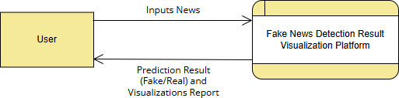

Figure 4.1 DFD Level 0

Components of the Level 0 DFD External Entity:
      - User:
The user interacts with the system by submitting news content for verification.

System Process:

      - Fake News Detection and Visualization Platform:

This process represents the entire fake news detection system, which includes preprocessing, feature extraction, machine learning prediction, and visualization.

Input Data:

News input in the form of:

- Text entered by the user
- URL of a news article
- Uploaded news file

Output Data:

The system returns:

- Prediction result (Fake or Real)
- Confidence score
- Visualization analytics

The Level 0 DFD provides a simplified overview of the system by showing the main interaction between the user and the fake news detection platform.

DFD Level 1

DFD Level 1 expands the Level 0 diagram by breaking the system into multiple processes and data stores. It provides a more detailed representation of how the system processes user input and generates results.

In the Fake News Detection and Visualization Platform, Level 1 DFD includes several key processes.

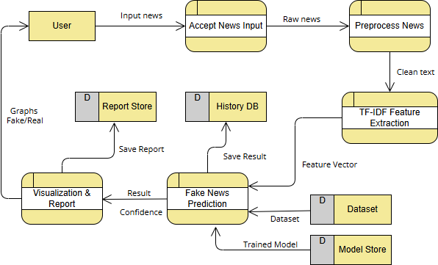

Figure 4.2 DFD Level 1

Process 1: Accept News Input

This process receives news input from the user. The input may be in the form of text, URL, or uploaded file. The system validates the input to ensure that it contains valid textual data that can be processed.

Process 2: Preprocess News

Before analysis, the text must be cleaned and standardized. The preprocessing stage includes several steps:

- Removing punctuation and special characters
- Converting text to lowercase
- Removing stop words such as "the", "is", and "and"
- Tokenizing the text into individual words
- Applying stemming or lemmatization to reduce words to their root forms

This step improves the efficiency and accuracy of machine learning models by removing unnecessary information from the text.

Process 3: TF-IDF Feature Extraction

Machine learning models cannot directly process raw text. Therefore, textual data must be converted into numerical features.

TF-IDF (Term Frequency–Inverse Document Frequency) is used to measure the importance of words within the news article. Words that appear frequently in a specific document but rarely in other documents receive higher weights.

The output of this stage is a feature vector, which represents the textual content numerically.

Process 4: Fake News Prediction

In this stage, the trained machine learning model analyzes the feature vector to determine whether the news article is fake or real.

The system uses a classification algorithm trained on labeled datasets. The model evaluates the input features and generates a prediction result along with a confidence score.

Process 5: Visualization and Report Generation

After prediction, the system generates visualization analytics to help users interpret the results. These visualizations may include:

- Word clouds
- Feature importance graphs
- Confidence score charts
- Prediction statistics

Data Stores

Several data stores are used within the system:

- Dataset

Contains training data used for machine learning model training.

- Model Store:

Stores trained machine learning models used for prediction.

- History Database:

Stores previous user queries and prediction results.

- Report Store:

Stores generated reports and visualization outputs.

The Level 1 DFD provides a detailed view of how the fake news detection system processes information internally.

Use Case Diagram

A Use Case Diagram represents the interaction between the user and the system. It describes the different operations that the user can perform within the Fake News Detection and Visualization Platform. The diagram helps to identify the system functionalities and the roles of different actors involved in the system.

In this system, the primary actor is the User, who interacts with the platform through the web interface. The user can provide news input in multiple formats such as text, URL, or file upload. The system then verifies the news using machine learning algorithms and provides the prediction results along with visual analytics.

The use case diagram identifies all the functionalities available to the user and the relationships between these functionalities.

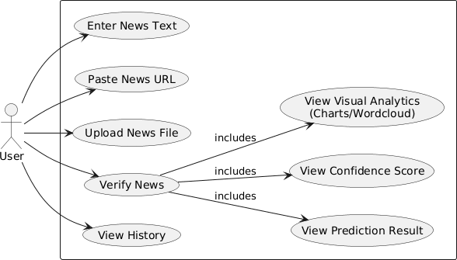

Figure 4.3 Use case diagram

Actor:

- User:

The user interacts with the system to verify the authenticity of news articles and view the results generated by the platform.

Use Cases:

- Enter News Text

This use case allows the user to manually enter news content directly into the system interface. The system receives the text and prepares it for analysis.

Paste News URL

The user can paste a URL of a news article from an external website. The system extracts the content from the URL and processes it for fake news detection.

Upload News File

The platform allows the user to upload a document containing news content. The system reads the file and extracts textual information for analysis.

Verify News

This is the core functionality of the system. Once the user provides the news input, the system processes the data and applies machine learning algorithms to classify the news as fake or real.

View Prediction Result

After verification, the system displays the classification result. The result indicates whether the news article is fake or real.

View Confidence Score

The system provides a confidence score representing the probability of the prediction. This score helps the user understand how confident the model is about its prediction.

View Visual Analytics

The platform generates visual representations of the analysis results. These may include charts, graphs, and word clouds that illustrate the important features influencing the prediction.

View History

The system stores previous queries and results in the history database. Users can access their past analyses and review previously verified news articles.
The Use Case Diagram helps to clearly define the functionality of the fake news detection platform from the user's perspective.

Class Diagram

The Class Diagram describes the structure of the system by identifying the classes, attributes, methods, and relationships between different system components. It provides a blueprint for the system architecture and helps developers understand how different objects interact with each other.

In the Fake News Detection and Visualization Platform, several classes are used to represent different components of the system.

User Class

The User class represents the individual interacting with the system.

Attributes:

- userId : int
- name : string

Methods:

- submitNews()
Allows the user to submit news input for verification.
- viewResult()
Allows the user to view the prediction results generated by the system.

NewsInput Class

The NewsInput class represents the news content provided by the user.

Attributes:

  - inputId : int
  - inputType : string
  - content : string

Methods:

- validateInput()
This method checks whether the input provided by the user is valid and contains appropriate textual information.

Model Class

The Model class represents the machine learning model responsible for fake news classification.

Attributes:

  - modelId : int
  - modelName : string
  - version : string

Methods:

- loadModel()
Loads the trained machine learning model from the model storage.
- predict()
Analyzes the input features and generates a prediction result.
- getConfidence()
Returns the confidence score associated with the prediction.

Result Class

The Result class stores the prediction results generated by the system.

Attributes:

  - resultId : int
  - label : string
  - confidence : float
  - dateTime : Date

The label represents whether the news article is fake or real.

Report Class

The Report class is responsible for generating reports and visualization outputs.

Attributes:

  - reportId : int
  - format : string
  - createdAt : Date

Methods:

- generate()
Generates visual reports based on prediction results.
- download()
Allows users to download the generated reports.

The relationships between these classes represent how data flows between different system components. For example, the Model class generates results that are stored in the Result class, which can then be used by the Report class to generate visual reports.

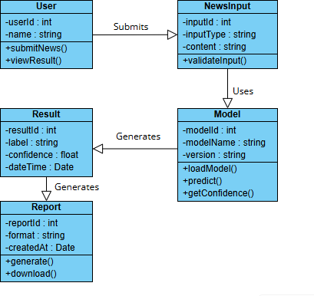

Figure 4.4 Class Diagram

State Diagram

A State Diagram represents the different states through which the system passes during its execution. It illustrates how the system transitions from one state to another based on user actions or internal processes.

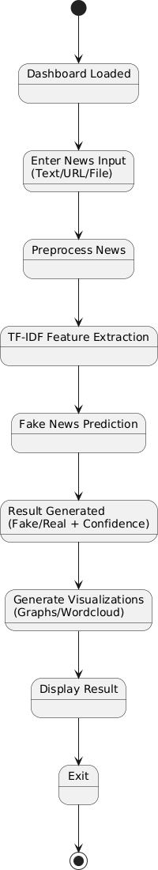

Figure 4.5 State Diagram

Initial State

The process begins when the platform is launched and the dashboard is loaded.

Dashboard Loaded

At this stage, the system interface becomes available for user interaction.

Enter News Input

The user enters news content using one of the available input methods such as text entry, URL input, or file upload.

Preprocess News

The system processes the input text by performing cleaning operations such as removing punctuation, converting text to lowercase, and removing stop words.

TF-IDF Feature Extraction

After preprocessing, the system converts the textual data into numerical feature vectors using the TF-IDF technique.

Fake News Prediction

The machine learning model analyzes the feature vectors and predicts whether the news article is fake or real.

Result Generated

The prediction result and confidence score are generated.

Generate Visualizations

The system creates visual analytics such as graphs and word clouds that represent the analysis results.

Display Result

The final result is displayed to the user through the system interface.

Exit

The process ends after the result is displayed and the user exits the system.

The State Diagram helps visualize the lifecycle of the fake news detection process.

Activity Diagram

An Activity Diagram illustrates the workflow of the system by showing the sequence of activities performed during fake news detection. It provides a clear representation of how different processes are executed within the platform.

The activity diagram begins when the user opens the platform.

Start

The system starts when the user accesses the web interface of the fake news detection platform.

Open Platform

The system loads the Streamlit-based user interface and prepares the environment for user interaction.

Enter News Input

The user provides news input by entering text, pasting a URL, or uploading a file.

Input Validation

      - The system verifies whether the provided input contains valid data.
      - If the input is invalid, the system displays an error message.
      - If the input is valid, the system proceeds to the next stage.

Text Preprocessing

The input text undergoes several preprocessing operations such as:

- Cleaning text
- Tokenization
- Stop word removal

- Stemming

Feature Extraction

TF-IDF feature extraction is applied to convert textual data into numerical features.

Model Prediction

The trained machine learning model analyzes the feature vectors and predicts whether the news article is fake or real.

Result Generation

The system generates the classification result along with a confidence score.

Visualization

Visual analytics such as charts and word clouds are generated.

Save Result

The query and prediction result are stored in the system history database.

End

The process ends after the result is displayed and saved.

The Activity Diagram helps illustrate the entire workflow of the fake news detection system.

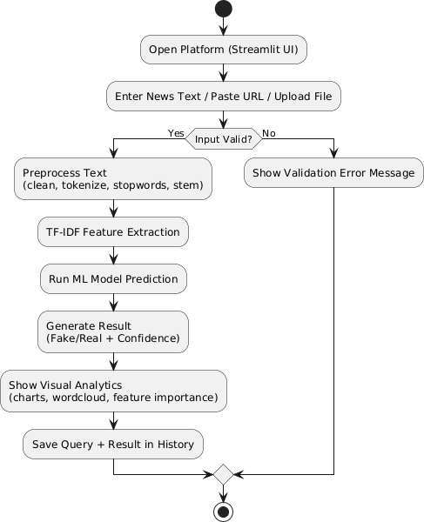

Figure 4.6 Activity Diagram

Sequence Diagram

The Sequence Diagram represents the interaction between different system components over time. It shows how messages are exchanged between objects to perform a particular task.

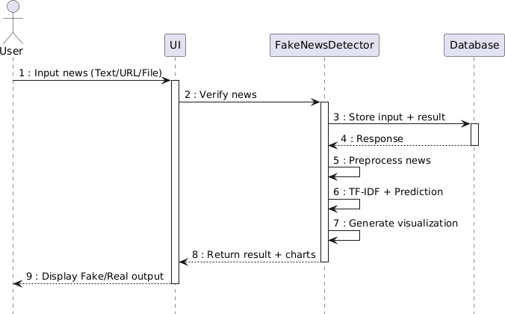

Figure 4.7 Sequence Diagram

In the Fake News Detection and Visualization Platform, the main components involved in the sequence diagram are:

    - User
    - User Interface (UI)
    - FakeNewsDetector
    - Database

Step 1: User Input

The user enters news input through the user interface.

Step 2: Verification Request

The user interface sends the news content to the FakeNewsDetector module for verification.

Step 3: Store Input

The FakeNewsDetector module stores the input data in the database.

Step 4: Preprocessing

The system preprocesses the text by cleaning and tokenizing the input content.

Step 5: Feature Extraction

TF-IDF feature extraction is performed to convert the text into numerical feature vectors.

Step 6: Prediction

The machine learning model analyzes the feature vectors and predicts whether the news is fake or real.

Step 7: Visualization Generation

The system generates visual analytics such as charts and graphs based on the prediction results.

Step 8: Return Result

The FakeNewsDetector sends the prediction results and visualizations back to the user interface.

Step 9: Display Output

The user interface displays the fake or real classification along with visual analytics.

The Sequence Diagram provides a clear understanding of how different system components communicate during the fake news detection process.

CHAPTER 5 METHODOLOGY
The methodology describes the approach used to design, implement, and evaluate the Fake News Detection and Visualization Platform. It explains how the system processes news input, applies machine learning techniques, and generates prediction results along with visualization analytics.

The proposed system follows a structured pipeline consisting of multiple stages including input collection, preprocessing, feature extraction, machine learning prediction, result generation, and visualization. The system also integrates data storage mechanisms to maintain history and reports for future reference.

The methodology ensures that the fake news detection process is efficient, accurate, and user- friendly. Each module of the system performs a specific task within the overall detection pipeline.

Module Descriptions

The Fake News Detection and Visualization Platform is composed of several functional modules. Each module performs a specific task in the overall system workflow. The modules work together to process the news input, analyze it using machine learning and semantic verification techniques, and present the results through interactive visualizations.

The main modules of the system are:

- Home / Dashboard Module
- Text Verification Engine
- Result Visualization Module
- Image Forensics Module
- URL Scanner Module
- Global Analytics Module

Each module is described in detail below.

Home / Dashboard Module

The Home module acts as the main entry point of the Fake News Detection Platform. When the system is launched, the user is presented with the dashboard interface where different functionalities of the platform are accessible.

The dashboard displays the project title “Project Sentinel: Fake News AI” along with the subtitle Multilingual Semantic Verification Engine. This interface provides navigation options that allow users to switch between different modules such as Text Engine, Image Forensics, URL Scanner, and Global Analytics.

The main objective of this module is to provide a user-friendly interface that allows users to easily interact with the system. It also organizes the different verification engines in a structured manner so that users can select the appropriate method for verifying news content.

The dashboard uses a modern web-based design implemented using the Streamlit framework. The interface includes clear navigation menus and input fields to guide the user through the verification process.


Figure 5.1 Home

Text Verification Engine

The Text Verification Engine is the core module of the system. This module allows users to verify textual news content such as headlines, WhatsApp forwards, or news claims.

Users can input text directly into the system using the provided text field. Once the text is entered, the user initiates the analysis by clicking the Initiate AI Scan button.

The system processes the input text through several stages:

      - Text preprocessing
      - Feature extraction using TF-IDF
      - Machine learning prediction
      - Semantic verification analysis
      - Result generation

During the verification process, the system compares the input news text with trusted online sources and evaluates its authenticity. The system calculates several metrics including trusted sources, peak match score, average match score, and machine learning confidence score.

This module plays a crucial role in identifying fake news by analyzing textual patterns and verifying the information against reliable sources.


Figure 5.2 Text Verification

Result Visualization Module

After the verification process is completed, the system displays the results through the Result Visualization Module. This module provides detailed insights into the analysis performed by the system.

The system classifies the news into categories such as:

- Real (Widely Reported)
- Likely Real
- Needs More Sources
- Not Verified

The result page also displays the Global Truth Index, which represents the overall credibility score of the news article. This score is calculated based on the semantic analysis and trusted source verification.

In addition to the truth index, the module also performs semantic entity extraction. This process identifies important keywords and entities present in the news article and displays them in graphical form.

The system also provides a list of trusted news sources that match the analyzed news article. These sources allow users to verify the authenticity of the information by accessing the original news publications.

This module enhances the transparency of the system by explaining the reasoning behind the prediction results.

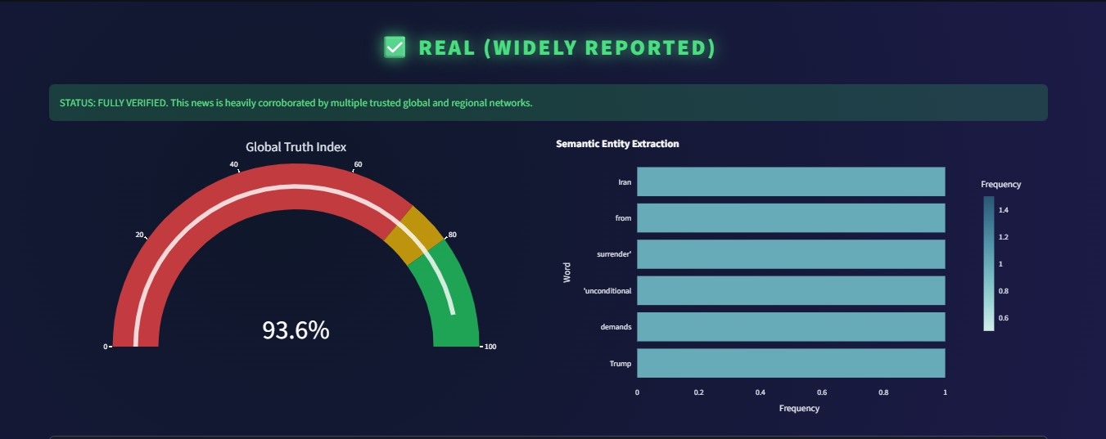

Figure 5.3 Result


Figure 5.4 Result

Image Forensics Module

Fake news often spreads through manipulated images and memes. The Image Forensics Module is designed to detect suspicious images that may contain misleading or altered content.

Users can upload image files such as screenshots, memes, or photographs. The system then performs forensic analysis to detect potential manipulations.

The module analyzes several aspects of the uploaded image including:

- Image metadata
- Pixel inconsistencies
- Possible image manipulation
- Content similarity with known images

The image verification process helps identify whether an image has been edited, reused from another context, or falsely associated with a news story.

This module plays an important role in combating visual misinformation, which is increasingly common on social media platforms.


Figure 5.5 Image Verifier

URL Scanner Module

The URL Scanner Module allows users to verify the authenticity of news articles by providing the URL of the news source.

When a user enters a URL, the system extracts the textual content of the webpage and analyzes it using the fake news detection pipeline.

The system performs the following operations:

      - Scrapes the webpage content
      - Extracts the news article text
      - Applies preprocessing techniques
      - Performs machine learning classification
      - Verifies the content using trusted news sources

The URL scanner helps users quickly verify the credibility of online news articles without manually copying the content.


Figure 5.6 URL Scanner

Global Analytics Module

The Global Analytics Module provides an overview of system performance and verification statistics. This module displays aggregated analytics related to news verification activities.

The analytics dashboard includes visual graphs such as:

- System traffic over time
- Verification outcome statistics
- Top trusted news sources
- Distribution of fake vs real news predictions

These visualizations help users understand how the system is being used and the trends observed in news verification results.

For example, the system traffic graph shows the number of verification requests processed by the platform over time. Similarly, the verification outcome chart displays the distribution of prediction results.

The analytics module helps administrators and researchers analyze the effectiveness of the fake news detection system.
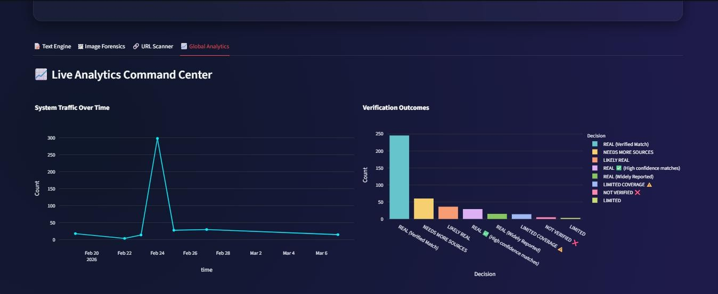

Figure 5.7 Global Analysis

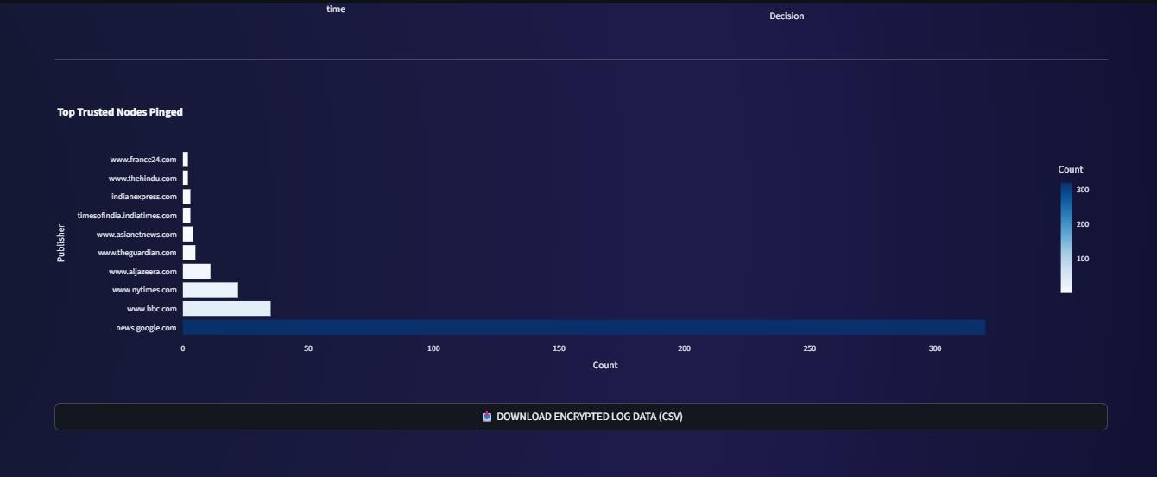

Figure 5.8 Global Analysis

Algorithms

The system uses machine learning algorithms for fake news classification. The key techniques used in the project include:

- TF-IDF Feature Extraction
- Machine Learning Classification Algorithm

TF-IDF Algorithm

The TF-IDF algorithm converts textual data into numerical features that can be used by machine learning models.

Steps:

- Count the frequency of each word in the document.
- Calculate how frequently each word appears across all documents.
- Assign higher weights to words that are unique to the document.
- Generate feature vectors representing the importance of each word.

Machine Learning Classification

Machine learning models learn patterns from training data and apply this knowledge to classify new inputs.

Steps:

- Load trained machine learning model
- Receive feature vector from TF-IDF module
- Analyze word patterns
- Generate prediction label
- Calculate confidence score

The trained model determines whether the news article is fake or real.

System Architecture

The system architecture of the Hybrid Fake News Detection and Visualization Platform describes the structural design and workflow of the proposed system. The architecture is designed to combine machine learning techniques with semantic artificial intelligence verification in order to improve the reliability and accuracy of fake news detection. The system follows a multi-stage processing pipeline that begins with news input and ends with prediction results and visualization analytics.

The architecture integrates two main analytical approaches: machine learning based textual classification and semantic AI based contextual verification. These two approaches operate in parallel and their outputs are combined using a Hybrid Verification Engine. This hybrid approach ensures that the system evaluates both statistical patterns within the text and the contextual meaning of the news content.

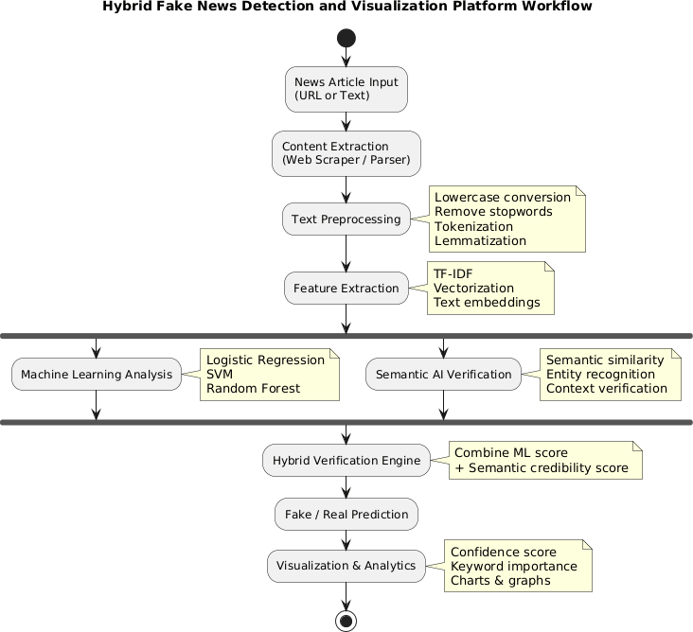

Figure 5.9 Architecture

The workflow begins when the system receives a news article input, which can be either a news text or a URL of an online article. If the input is provided as a URL, the system uses a content extraction module that utilizes web scraping or parsing techniques to extract the relevant textual content from the webpage. Web pages often contain advertisements, navigation menus, and multimedia elements that are not useful for analysis. Therefore, the content extraction module isolates the main body of the news article and removes unnecessary elements.

After the news content is extracted, the system performs text preprocessing to clean and standardize the textual data. Preprocessing includes converting all text to lowercase to maintain uniformity, removing stop words such as “the”, “is”, and “and” that do not contribute

meaningful information, performing tokenization to break the text into individual words, and applying lemmatization to reduce words to their root forms. These preprocessing steps improve the quality of the textual data and help machine learning models analyze the content more effectively.

Once the text is preprocessed, the system performs feature extraction to convert the textual data into numerical representations that can be processed by machine learning algorithms. The system uses techniques such as TF-IDF vectorization to measure the importance of words within the document relative to the dataset. Additionally, text embeddings may be used to represent semantic relationships between words in a numerical vector space. The output of this stage is a feature vector that represents the news article in numerical form.

The feature vectors are then processed by the machine learning analysis module, which applies trained classification algorithms to determine the authenticity of the news article. Several machine learning algorithms can be used for this purpose, including Logistic Regression, Support Vector Machines (SVM), and Random Forest classifiers. These algorithms analyze statistical patterns in the textual data and generate a prediction score indicating the likelihood that the news article is fake or genuine.

Alongside the machine learning analysis, the system performs semantic AI verification to evaluate the contextual credibility of the news article. While machine learning models rely mainly on statistical patterns, semantic analysis focuses on understanding the meaning and relationships between entities mentioned in the text. This module performs tasks such as semantic similarity analysis, entity recognition, and contextual verification. Semantic similarity analysis compares the news content with information available from trusted sources, while entity recognition identifies key entities such as people, organizations, and locations mentioned in the article. Context verification evaluates whether the relationships between these entities are logically consistent.

The outputs generated by the machine learning analysis module and the semantic AI verification module are then combined by the Hybrid Verification Engine. This engine integrates the machine learning prediction score with the semantic credibility score to produce a final credibility evaluation. By combining these two independent analyses, the system

reduces the limitations of individual methods and improves the overall accuracy of fake news detection.

Based on the hybrid credibility score, the system generates the final prediction result, classifying the news article as either Fake News or Real News. The system also provides a confidence score that represents the probability of the prediction result.

In the final stage, the system presents the results through a visualization and analytics module. This module generates graphical representations that help users understand the analysis process. These visualizations may include confidence score charts, keyword importance graphs, word clouds, and other statistical visualizations. By presenting the results in graphical form, the system improves transparency and allows users to better interpret the factors that influenced the classification decision.

Overall, the hybrid architecture enables the Fake News Detection and Visualization Platform to analyze news content using both statistical machine learning methods and semantic contextual verification. This integrated approach enhances the reliability of fake news detection and provides meaningful insights through visualization analytics.

CHAPTER 6 IMPLEMENTATION DETAILS
The implementation phase involves translating the system design and methodology into a working software application. In this project, the Fake News Detection and Visualization Platform was implemented using Python-based technologies and machine learning libraries. The system integrates natural language processing techniques, machine learning models and visualization tools to provide a complete platform for verifying news authenticity.

The implementation focuses on developing a reliable pipeline that processes user input, performs text analysis, predicts whether the news is fake or real, and displays the results through interactive visualizations. This chapter explains the technologies used, system setup, development steps, datasets, and testing procedures used to evaluate the performance of the system.

Implementation Procedures

The implementation of the Fake News Detection and Visualization Platform was carried out in several stages. Each stage focuses on a specific aspect of the system such as data collection, preprocessing, model training, interface development, and result visualization.

The system was implemented using Python because of its extensive support for machine learning, natural language processing, and web-based visualization tools.

Development Environment

The development environment used for implementing the system consists of both software tools and libraries that support machine learning and data analysis.

Programming Language

Python was used as the primary programming language due to its flexibility and extensive ecosystem of machine learning libraries.

Framework

Streamlit was used to build the web interface for the fake news detection platform. Streamlit provides an easy way to create interactive web applications using Python.

Libraries Used

Several Python libraries were used in the implementation:

Pandas
Used for handling and analyzing structured data.

NumPy
Provides support for numerical computations and array operations.

Scikit-learn
Used for implementing machine learning algorithms and feature extraction methods.

NLTK (Natural Language Toolkit)

Used for performing natural language processing tasks such as tokenization and stop word removal.

Matplotlib and Seaborn

Used for generating visualization charts and graphs.

WordCloud
Used to generate word clouds for visualization of important words.

Dataset Collection

The performance of the fake news detection model depends heavily on the dataset used for training and testing.

For this project, publicly available fake news datasets were used. These datasets contain labeled news articles classified as either fake or real.

Common datasets used in fake news detection include:

      - FakeNewsNet Dataset
      - Kaggle Fake News Dataset
      - LIAR Dataset

Each dataset contains several fields such as:

      - News article text
      - Author
      - Publication source
      - Label (Fake or Real)

The dataset was divided into training and testing sets to evaluate the performance of the model.

Data Preprocessing Implementation

Before training the machine learning model, the dataset must be cleaned and processed. Raw textual data often contains unnecessary elements that may affect the performance of the classification model.

The preprocessing stage was implemented using natural language processing techniques. The following preprocessing steps were applied:

Removing Special Characters

Special characters, punctuation marks, and numbers were removed from the text to ensure that only meaningful words remain.

Lowercase Conversion

All words were converted to lowercase to avoid treating the same word differently due to capitalization.

Tokenization

The text was divided into smaller units called tokens. Each token represents an individual word.

Stop Word Removal

Stop words such as "the", "is", and "and" were removed from the text because they do not provide significant meaning in classification.

Stemming

Words were reduced to their root forms to group similar words together. Example:
- running → run
- playing → play

These preprocessing steps help reduce noise in the dataset and improve model accuracy.

Feature Extraction Implementation

Machine learning models require numerical input. Therefore, textual data must be converted into numerical features.

In this project, TF-IDF vectorization was used to convert the processed text into numerical vectors.

The TF-IDF vectorizer calculates the importance of each word based on its frequency within the document and across the dataset.

The process involves:

- Calculating term frequency for each word in the document.
- Calculating inverse document frequency across the dataset.
- Multiplying TF and IDF values to obtain TF-IDF scores.

The resulting feature vectors represent the textual content numerically and can be used as input to machine learning algorithms.

Machine Learning Model Implementation

After feature extraction, a machine learning model was trained to classify news articles as fake or real.

Several machine learning algorithms can be used for fake news detection, including:

      - Logistic Regression
      - Support Vector Machine
      - Random Forest
      - Naïve Bayes

In this project, a classification algorithm was trained using the processed dataset. The model training process involved:
- Splitting the dataset into training and testing sets.
- Training the model using the training dataset.
- Evaluating the model using the testing dataset.

The trained model was then saved and integrated into the web application for real-time prediction.

Web Interface Implementation

The user interface of the system was implemented using Streamlit. Streamlit allows developers to create web applications using Python without requiring complex frontend development.

The interface includes several components:

Input Section

Users can submit news input using:

      - Text input box
      - URL input field
      - File upload option

Prediction Section

After input is submitted, the system displays the prediction result indicating whether the news is fake or real.

Visualization Section

The interface displays visual analytics such as:

      - Word cloud
      - Feature importance charts
      - Prediction confidence graphs

The interactive interface improves user experience and makes the system easier to use.

Testing Methods and Results

Testing is an important step in the implementation process. It ensures that the system functions correctly and produces accurate predictions.

Testing was performed using multiple evaluation techniques.

Dataset Testing

The dataset was divided into two parts:

      - Training Dataset

Used to train the machine learning model.

      - Testing Dataset

Used to evaluate the performance of the model.

A common approach is the 80–20 split:

- 80% training data
- 20% testing data

This approach ensures that the model is evaluated on unseen data.

Model Evaluation Metrics

Several evaluation metrics were used to measure the performance of the fake news detection model.

Accuracy

Accuracy measures the percentage of correct predictions made by the model. Accuracy = (Correct Predictions / Total Predictions) × 100

Precision

Precision measures how many predicted fake news articles are actually fake. Precision = True Positives / (True Positives + False Positives)

Recall

Recall measures how many actual fake news articles were correctly identified. Recall = True Positives / (True Positives + False Negatives)

F1 Score

The F1 score combines precision and recall to provide a balanced evaluation metric. F1 Score = 2 × (Precision × Recall) / (Precision + Recall)

Confusion Matrix

A confusion matrix was used to evaluate the classification results of the model. The confusion matrix contains four components:
      - True Positive (TP) – Fake news correctly identified as fake
      - True Negative (TN) – Real news correctly identified as real
      - False Positive (FP) – Real news incorrectly identified as fake
      - False Negative (FN) – Fake news incorrectly identified as real

The confusion matrix provides a clear visualization of the classification performance.

System Testing

In addition to model evaluation, the entire system was tested to ensure proper functionality.

Input Validation Testing

The system checks whether the user input contains valid news content.

Prediction Testing

The system verifies that the machine learning model generates predictions correctly.

Visualization Testing

The system ensures that charts and graphs are displayed properly.

Database Testing

The system verifies that user queries and results are stored correctly in the history database.

Testing Results

The experimental results showed that the fake news detection model achieved high classification accuracy when tested on unseen data.

The results demonstrate that the proposed system is capable of effectively detecting fake news articles and providing useful visualization insights to users.

CHAPTER 7 ADVANTAGES AND DISADVANTAGES
The Fake News Detection and Visualization Platform was designed to automatically analyze news content and determine whether it is fake or genuine using machine learning techniques and visualization tools. While the system provides several benefits in combating misinformation, it also has certain limitations due to the complexity of fake news detection and the challenges associated with natural language processing.

This chapter discusses the advantages and disadvantages of the proposed system to provide a balanced evaluation of its capabilities.

Advantages

The Fake News Detection and Visualization Platform offers several advantages in terms of efficiency, usability, and analytical capability. The system provides an automated approach for verifying the authenticity of news articles and helps users understand the prediction results through visual analytics.

Automated Fake News Detection

One of the major advantages of the system is the ability to automatically detect fake news. Instead of relying on manual verification by fact-checkers or journalists, the platform uses machine learning algorithms to analyze textual content and identify misleading information.

The automated detection process reduces the time required to verify news authenticity and allows users to quickly determine whether a news article is trustworthy.

Faster Verification Process

Manual fact-checking can be time-consuming and requires significant human effort. The proposed system can analyze news content within seconds and provide immediate results.

This rapid verification capability is particularly useful in situations where misinformation spreads quickly on social media platforms. By providing quick analysis results, the system helps prevent the rapid spread of false information.

Hybrid Analysis Approach

The system combines multiple techniques such as natural language processing, feature extraction, and machine learning classification. This hybrid analytical approach improves the reliability of fake news detection.

The integration of TF-IDF feature extraction and machine learning algorithms enables the system to identify patterns within textual data and classify news articles effectively.

Visualization of Results

Another important advantage of the system is the use of visualization tools to display the analysis results. Instead of presenting only textual predictions, the system provides visual insights such as charts, graphs, and word clouds.

These visual representations help users understand how the system arrived at a particular prediction. Visualization also improves transparency and enhances user trust in the system.

User-Friendly Interface

The platform is designed with a simple and intuitive user interface that allows users to easily interact with the system. Users can submit news input using text entry, URL input, or file upload options.

The Streamlit-based interface ensures that users can quickly analyze news content without requiring technical knowledge of machine learning or data analysis.

Scalability

The system architecture is modular, which means that different components of the system can be upgraded or replaced without affecting the entire platform.

For example, the machine learning model can be replaced with a more advanced deep learning model in the future without changing the user interface or preprocessing modules.

This scalability allows the system to evolve and adapt to new fake news detection techniques.

Data Storage and History Tracking

The system maintains a history of previously analyzed news articles and their prediction results. This feature allows users to review past analyses and track patterns in misinformation.

Storing historical data also helps researchers evaluate the performance of the system and improve detection algorithms in the future.

Disadvantages

Despite its advantages, the Fake News Detection and Visualization Platform also has certain limitations. These limitations arise mainly from the complexity of fake news detection and the evolving nature of misinformation.

Dependence on Dataset Quality

The accuracy of the fake news detection model depends heavily on the dataset used for training. If the dataset contains biased or incomplete information, the model may produce incorrect predictions.

For example, if the dataset mainly contains political news articles, the model may not perform well when analyzing news from other domains such as healthcare or technology.

Difficulty in Detecting Sophisticated Fake News

Some fake news articles are written in a style that closely resembles legitimate news content. These articles may include credible references, realistic writing styles, and manipulated images.

Machine learning models that rely primarily on textual analysis may struggle to detect such sophisticated misinformation.

Limited Context Understanding

Although natural language processing techniques help analyze textual content, machines still struggle to fully understand the context and deeper meaning of language.

For example, satire, sarcasm, and humor may be misclassified as fake news by automated detection systems.

This limitation highlights the challenge of interpreting human language accurately using computational methods.

Continuous Evolution of Fake News

Fake news creators constantly adapt their strategies to bypass detection systems. They may use new writing styles, misinformation techniques, or multimedia manipulation methods.

As a result, fake news detection models must be regularly updated and retrained with new datasets to maintain their effectiveness.

Limited Multimodal Analysis

The current system primarily focuses on textual analysis. However, many fake news articles contain manipulated images, videos, or multimedia content.

Without analyzing these additional data sources, the system may fail to detect certain types of misinformation.

Future systems should incorporate multimodal analysis techniques to analyze text, images, and videos simultaneously.

Computational Resource Requirements

Machine learning models require computational resources for training and prediction. When analyzing large datasets or deploying more advanced deep learning models, the system may require higher processing power and memory.

Although the current system is efficient for small to medium-scale datasets, large-scale deployment may require additional computational infrastructure.

Summary:

The Fake News Detection and Visualization Platform provides an efficient and user-friendly approach for identifying misleading news articles using machine learning techniques. The system offers advantages such as automated detection, faster verification, visualization support, and scalability.

However, challenges such as dataset limitations, evolving misinformation strategies, and limited contextual understanding highlight the need for continuous improvement in fake news detection technologies.

Understanding both the advantages and limitations of the system helps researchers identify areas for improvement and develop more advanced fake news detection solutions in the future.

CHAPTER 8 RESULTS AND DISCUSSION
The Results and Discussion chapter presents the outcomes obtained from the implementation of the Hybrid Fake News Detection and Visualization Platform. This chapter evaluates how effectively the system performs fake news detection using machine learning and semantic verification techniques. It also discusses the insights obtained from the analysis results and visualization outputs generated by the system.

The primary objective of this project is to build a system capable of identifying whether a news article is genuine or fake using automated analysis. The system processes news input through several stages including preprocessing, feature extraction, machine learning classification, semantic verification, and visualization of results.

The experimental results demonstrate the ability of the system to analyze textual news content, compare it with trusted sources, and provide meaningful credibility scores. The results also show that combining machine learning techniques with semantic verification improves the reliability of fake news detection.

System Output Overview`

When a user submits a news article or headline into the platform, the system performs a complete analysis and produces several outputs. These outputs help users understand the credibility of the news article.

The main outputs generated by the system include:

    - Fake or Real prediction
    - Confidence score of the prediction
    - Global truth index score
    - Semantic entity extraction
    - Trusted source verification results
    - Visualization analytics

The system interface presents these outputs through an interactive dashboard that displays charts, graphs, and statistical insights.

Prediction Results

The fake news detection model classifies news articles into different credibility categories. These categories help users interpret the reliability of the news content.

The possible prediction outcomes generated by the system include:

Real (Widely Reported):

This classification indicates that the news article is confirmed by multiple trusted news sources and is highly credible.

Likely Real:

This indicates that the article appears to be authentic but may not be widely reported across multiple sources.

Needs More Sources:

This classification indicates that the news article requires additional verification from trusted sources before confirming its authenticity.

Not Verified:

This result suggests that the system could not find sufficient evidence supporting the news article.

For example, when the system analyzed a news headline related to international politics, the system generated the following output:

Prediction Result: REAL (Widely Reported): Confidence Score: 93.6%

This indicates that the news article was verified by several trusted global news sources and is considered credible.

Trusted Source Matching

One of the important features of the proposed system is its ability to verify news content by comparing it with trusted sources available online.

The system performs semantic similarity analysis to find similar news articles published by reliable news organizations. When matching sources are found, the system displays a list of trusted news outlets along with their similarity scores.

For example, when analyzing a political news headline, the system identified matching articles from trusted sources such as:

    - BBC News
    - Google News
    - International Business Times
    - The Times

Each source is associated with an AI match score that represents the similarity between the input news article and the trusted source.

The presence of multiple trusted sources significantly increases the credibility of the analyzed news article.

Global Truth Index

The Global Truth Index is a credibility score generated by the system to represent the authenticity of the analyzed news article. This index is calculated based on several factors including:

    - Machine learning prediction score
    - Semantic similarity analysis
    - Trusted source verification

    - Context verification results

The truth index ranges from 0 to 100, where higher values indicate higher credibility. For example:
Truth Index: 93.6%

This score indicates that the news article has strong verification evidence and is considered highly reliable.

The truth index is displayed using a gauge-style visualization that allows users to easily interpret the credibility level of the news article.

Semantic Entity Extraction

The system also performs semantic entity extraction to identify important keywords and entities mentioned in the news article. These entities include names of people, organizations, locations, and key events.

For example, when analyzing a political news article, the system extracted entities such as:

    - Trump
    - Iran
    - President
    - Surrender
    - Demands

These entities are displayed in a graphical chart showing their frequency in the analyzed text. Entity extraction helps the system understand the context of the news article and improves semantic verification accuracy.

Visualization, Analytics, System Performance Evaluation, and Discussion
Visualization and analytics help improve the transparency and understanding of the Fake News Detection and Visualization Platform. Instead of showing only a prediction result, the system provides graphical insights that explain how the analysis was performed.

One of the key visualizations is the Truth Index Gauge Chart, which represents the credibility score of the analyzed news article. The chart uses color-coded regions where red indicates low credibility, yellow indicates moderate credibility, and green represents high credibility. This helps users quickly understand whether the news content is reliable.

The system also generates an Entity Frequency Chart, which displays the most important keywords extracted from the news article. These entities represent key topics such as people, locations, or organizations mentioned in the text. This visualization helps users understand the context of the news content.

Another feature is Verification Outcome Analytics, which shows the distribution of prediction results such as Real (Verified Match), Needs More Sources, Likely Real, Limited Coverage, and Not Verified. This helps analyze how frequently each category appears during verification.

The platform also provides System Traffic Analysis, which shows the number of verification requests processed over time. This helps evaluate system usage patterns. Additionally, Trusted Source Analysis identifies the most frequently matched reliable publishers such as Google News, BBC, The New York Times, Al Jazeera, and The Guardian.

The system performance was evaluated using metrics such as prediction accuracy, response time, and reliability. The hybrid approach combining machine learning with semantic verification improves detection performance compared to single-method systems. The platform can analyze news articles and generate results within a few seconds, making it suitable for real- time fake news detection.

Overall, the results demonstrate that the hybrid fake news detection system effectively identifies misinformation and provides meaningful insights through visualization. However,

detecting fake news remains challenging due to the evolving nature of misinformation. Future improvements may include advanced deep learning models, image verification techniques, and multimodal analysis methods to further enhance detection accuracy.

CHAPTER 9 CONCLUSION

Summary

The rapid growth of digital media and social networking platforms has significantly increased the spread of misinformation across the internet. Fake news has become a major challenge for society because misleading information can influence public opinion, create social confusion, and damage the credibility of legitimate news sources. This project aimed to develop an intelligent system capable of detecting fake news and presenting the results in a clear and understandable manner.

The proposed Fake News Detection and Visualization Platform uses a hybrid verification approach that combines machine learning techniques with semantic artificial intelligence methods. The system analyzes news articles through multiple stages including input processing, text preprocessing, feature extraction, machine learning classification, semantic verification, and visualization of results. This hybrid approach improves the reliability of fake news detection by analyzing both statistical patterns and contextual meaning within the news content.

The system allows users to verify news through multiple methods such as text verification, URL scanning, and image forensics. The platform extracts textual information from the input news article and processes it using natural language processing techniques. Feature extraction methods such as TF-IDF are used to convert textual data into numerical representations that can be analyzed by machine learning models. The machine learning module predicts whether the news article is fake or real, while the semantic verification module checks the contextual credibility by comparing the content with trusted sources.

Another important feature of the system is the visualization module, which presents the results through graphical analytics such as truth index charts, entity frequency graphs, and verification outcome statistics. These visualizations improve transparency and help users understand how the system reached its prediction.

The implementation results show that the system is capable of analyzing news articles efficiently and generating prediction results within a short time. The hybrid approach used in the system enhances the detection accuracy and provides meaningful insights through visualization tools.

Limitations

Although the proposed system performs well in detecting fake news, certain limitations still exist. Fake news detection is a complex problem because misinformation continuously evolves with new techniques and strategies.

One limitation of the system is its dependence on the dataset used for training the machine learning model. If the dataset does not contain sufficient examples from different domains, the model may struggle to generalize to new types of news articles.

Another limitation is that the current system primarily focuses on textual analysis. However, many fake news articles include manipulated images, videos, or multimedia content that may not be detected using text analysis alone.

The system also relies on the availability of trusted sources for semantic verification. In cases where reliable sources are not available, the system may classify the news as “Needs More Sources” instead of providing a definitive result.

Additionally, natural language processing techniques may sometimes struggle to interpret sarcasm, satire, or complex linguistic expressions present in news articles.

Future Scope

There are several opportunities to improve and extend the Fake News Detection and Visualization Platform in the future.

One potential improvement is the integration of advanced deep learning models such as transformer-based architectures (BERT or GPT-based models) that can better understand contextual relationships within text. These models can improve the accuracy of fake news detection by capturing deeper semantic meaning.

Another possible enhancement is the inclusion of multimodal analysis, which would allow the system to analyze not only textual content but also images, videos, and audio. This would help detect fake news that spreads through manipulated multimedia content.

The system could also be integrated with real-time social media monitoring tools to automatically detect fake news trends across platforms such as Twitter, Facebook, and online news websites.

Another future improvement could involve the development of browser extensions or mobile applications that allow users to verify news articles directly while browsing the internet.

Furthermore, integrating knowledge graphs and fact-checking databases could enhance the
system’s ability to verify factual claims present in news articles.

Applications

The Fake News Detection and Visualization Platform has several practical applications in different domains.

One important application is in journalism and media organizations, where journalists can use the system to verify the credibility of news articles before publishing them. This can help maintain journalistic integrity and prevent the spread of misinformation.

The system can also be used by social media platforms to identify misleading content shared by users. Automated fake news detection tools can help reduce the spread of misinformation across social networks.

Another application is in government and public policy organizations, where authorities can monitor and identify fake news that may cause social unrest or misinformation during important events such as elections or public health crises.

Educational institutions can also benefit from this system by using it as a learning tool for media literacy, helping students understand how fake news spreads and how it can be detected.

Finally, the platform can be used by general internet users who want to verify the authenticity of news articles before sharing them online.

CHAPTER 10 APPENDICES

Click the link below:

- https://fakenewsaibyxac.streamlit.app
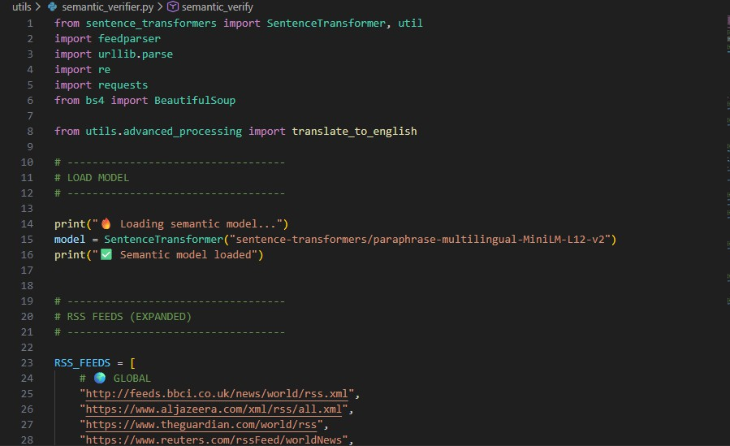
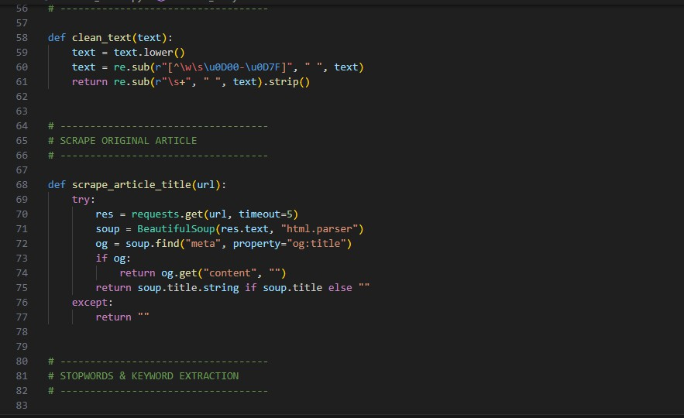

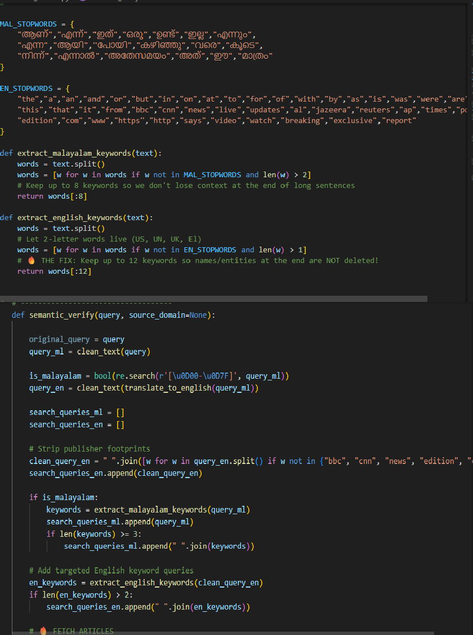

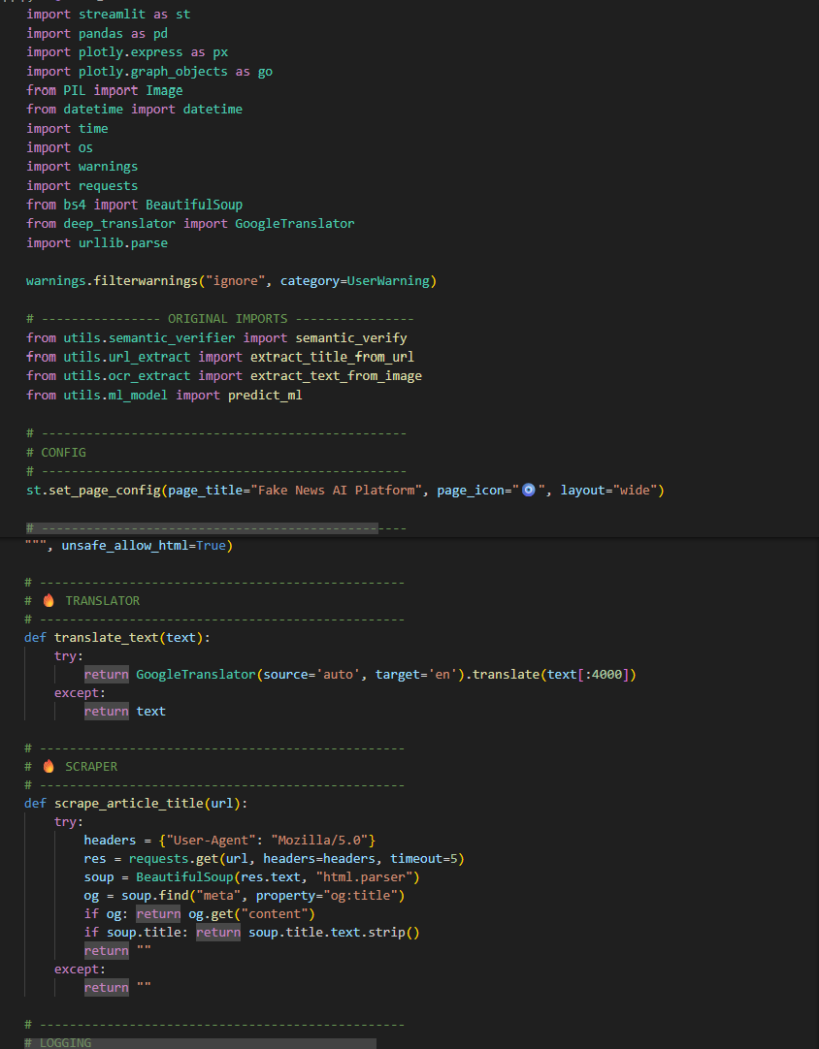

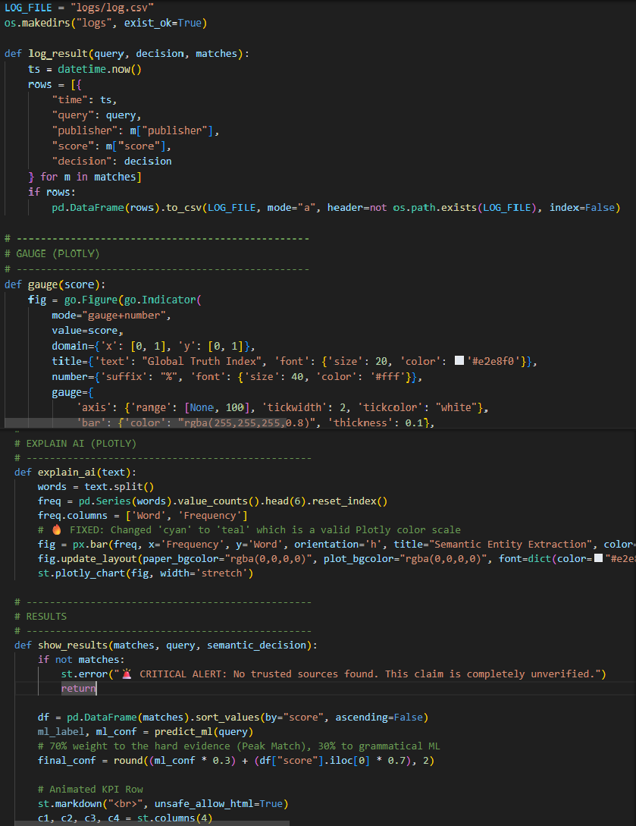

CHAPTER 11 REFERENCES
- K. Soga, S. Yoshida, and M. Muneyasu, “Graph-Based Interpretability for Fake News Detection through Topic- and Propagation-Aware Visualization,” Computation, vol. 12, no. 82, 2024.

- A. Mishra and H. Sadia, “A Comprehensive Analysis of Fake News Detection Models: A Systematic Literature Review and Current Challenges,” Engineering Proceedings, vol. 59, no. 28, 2023.

- K. Nath, A. Ahuja, P. Soni, R. Katarya, and Anjum, “Study of Fake News Detection Using Machine Learning and Deep Learning Classification Methods,” in Proc. IEEE Int. Conf. on Computing and Communication, 2023.

- S. Yakkundi, R. Patil, and S. Sangani, “Exploring Machine Learning for Fake News Detection: Techniques, Tools, Challenges, and Future Research Directions,” Discover Applied Sciences, vol. 7, 2025.

- S. K. Hamed, M. J. A. Aziz, and M. R. Yaakub, “Fake News Detection Model on Social Media by Leveraging Sentiment Analysis of News Content and Emotion Analysis of Users’ Comments,” Sensors, vol. 23, no. 1748, 2023.

- K. Shu, A. Sliva, S. Wang, J. Tang, and H. Liu, “Fake News Detection on Social Media: A Data Mining Perspective,” ACM SIGKDD Explorations Newsletter, vol. 19, no. 1, pp. 22–36, 2017.

- W. Y. Wang, “Liar, Liar Pants on Fire: A New Benchmark Dataset for Fake News Detection,” in Proc. 55th Annual Meeting of the Association for Computational Linguistics, 2017, pp. 422–426.

- K. Shu, S. Wang, and H. Liu, “Beyond News Contents: The Role of Social Context for Fake News Detection,” in Proc. ACM Int. Conf. on Web Search and Data Mining, 2019.

- J. Devlin, M. Chang, K. Lee, and K. Toutanova, “BERT: Pre-training of Deep Bidirectional
Transformers for Language Understanding,” in Proc. NAACL-HLT, 2019.

- T. Mikolov et al., “Efficient Estimation of Word Representations in Vector Space,” in
Proc. International Conference on Learning Representations (ICLR), 2013.

- Y. Kim, “Convolutional Neural Networks for Sentence Classification,” in Proc. EMNLP, 2014.

- T. Chen and C. Guestrin, “XGBoost: A Scalable Tree Boosting System,” in Proc. ACM SIGKDD International Conference on Knowledge Discovery and Data Mining, 2016.

- P. Ruchansky, S. Seo, and Y. Liu, “CSI: A Hybrid Deep Model for Fake News Detection,”
in Proc. ACM Conference on Information and Knowledge Management, 2017.

- S. Vosoughi, D. Roy, and S. Aral, “The Spread of True and False News Online,” Science, vol. 359, no. 6380, pp. 1146–1151, 2018.

- N. J. Conroy, V. L. Rubin, and Y. Chen, “Automatic Deception Detection: Methods for Finding Fake News,” Proceedings of the Association for Information Science and Technology, vol. 52, no. 1, 2015.

- K. Shu, D. Mahudeswaran, and H. Liu, “FakeNewsNet: A Data Repository with News Content, Social Context, and Spatiotemporal Information for Studying Fake News on Social Media,” Big Data, vol. 8, no. 3, pp. 171–188, 2020.

- S. Hochreiter and J. Schmidhuber, “Long Short-Term Memory,” Neural Computation, vol. 9, no. 8, pp. 1735–1780, 1997.

- T. Pedregosa et al., “Scikit-learn: Machine Learning in Python,” Journal of Machine Learning Research, vol. 12, pp. 2825–2830, 2011.

- F. Pedregosa et al., “Machine Learning and Data Mining Approaches for Fake News Detection,” IEEE Access, vol. 7, pp. 152732–152742, 2019.

- R. Zellers et al., “Defending Against Neural Fake News,” in Proc. Advances in Neural Information Processing Systems (NeurIPS), 2019.

- Y. Zhou and R. Zafarani, “Fake News: A Survey of Research, Detection Methods, and Opportunities,” ACM Computing Surveys, vol. 53, no. 5, 2021.

- A. Monti et al., “Fake News Detection on Social Media using Geometric Deep Learning,”
IEEE Transactions on Knowledge and Data Engineering, 2021.

- S. Bird, E. Klein, and E. Loper, Natural Language Processing with Python. Sebastopol,
CA: O’Reilly Media, 2009.

- A. Géron, Hands-On Machine Learning with Scikit-Learn, Keras, and TensorFlow.
O’Reilly Media, 2019.

- T. Mitchell, Machine Learning. New York, NY, USA: McGraw-Hill, 1997.

